Bac-In - Referral form

NOTE: You are advised to visit the Bac-In website at https://www.bac-in.org/ before making this referral. The website has full description of all Bac-in services and will help to ensure that this referral is appropriate to our service.

Please tick to confirm consent has been received from the client for this referral to be made and for BAC-IN to contact them using the information details you have provided below | YES ☐ NO ☐

Referral Type: (please tick relevant) | Self ☐ Family ☐ Friend ☐ Professional ☐ Other ☐

Date: | Click or tap to enter a date. | Time: | Click or tap here to enter text.

Referrer Details
Organisation: (if applicable) | Click or tap here to enter text.
Full Name: | Click or tap here to enter text.
Address:  Postcode: | Click or tap here to enter text.
Contact number | Click or tap here to enter text.
Email | Click or tap here to enter text.
Please provide details of why you are making this referral:
Click or tap here to enter text.

Client Details
Title  (Please circle) | Mr ☐ Miss ☐ Mrs ☐ Ms ☐ Other  Click or tap here to enter text.
First Name: | Click or tap here to enter text. | Surname: | Click or tap here to enter text.
Address:  Postcode: | Click or tap here to enter text.  Click or tap here to enter text.
Tel number: | Click or tap here to enter text.
Email: | Click or tap here to enter text.
Please confirm we are able to use the details above to contact the client
YES NO

Date of birth: | Click or tap to enter a date.
NI Number: | Click or tap here to enter text.
NHS Number: | Click or tap here to enter text.
Ethnicity: | Click or tap here to enter text.
Gender (please tick)
Male | ☐
Female | ☐
Not known | ☐
Not specified | ☐
Other: | ☐

Are there any risks associated in relation to contacting the client? YES NO
If yes please provide specify below:
Click or tap here to enter text.

GP Details
GP Name: | Click or tap here to enter text.
GP Surgery: | Click or tap here to enter text.
Address:  Postcode: | Click or tap here to enter text.  Click or tap here to enter text.
Tel number: | Click or tap here to enter text.
Email: | Click or tap here to enter text.
Is the GP aware of the client’s substance misuse?
YES ☐ NO ☐ Not known ☐
Additional Requirements
Does the client speak English? |  | YES ☐ NO ☐
Is the client able to read and write in English? |  | YES ☐ NO ☐
Is an interpreter required?  (If yes please specify language) |  | YES ☐ NO ☐  Specify Language:
Does the client have any Physical Disability?  (If yes please provide details of any support requirements) |  | YES ☐ NO ☐  Click or tap here to enter text.

Client Substance Misuse
Substance of choice | Drug name | Frequency of use | Method of use if known (smoke/inject/ingest)
Primary substance | Click or tap here to enter text. | Click or tap here to enter text. | Click or tap here to enter text.
Secondary substance | Click or tap here to enter text. | Click or tap here to enter text. | Click or tap here to enter text.
Other substances | Click or tap here to enter text. | Click or tap here to enter text. | Click or tap here to enter text.

AUDIT-C (Please refer to Appendix A for details on unit equations)
Questions | Scoring system |  |  |  |  | Your score
 | 0 | 1 | 2 | 3 | 4
How often do you have a drink containing alcohol? | Never | Monthly  or less | 2 - 4 times per month | 2 - 3 times per week | 4+ times per week | Click or tap here to enter text.
How many units of alcohol do you drink on a typical day when you are drinking? | 0 - 2 | 3 - 4 | 5 - 6 | 7 - 9 | 10+ | Click or tap here to enter text.
How often have you had 6 or more units if female, or 8 or more if male, on a single occasion in the last year? | Never | Less than monthly | Monthly | Weekly | Daily or almost daily | Click or tap here to enter text.
Scoring  A total of 5+ indicates increasing or higher risk drinking.  An overall total score of 5 or above is AUDIT-C positive. | AUDIT-C Score |  |  |  |  | Click or tap here to enter text.
Use the space below to tell us about anything else you feel is important to know about their drugs or alcohol use
Click or tap here to enter text.

Risk Screening (Please tick relevant)
Pregnancy | ☐ | Safeguarding Children / Childcare Concern |  | ☐ | Injecting Drug Use | ☐
Physical Health Concerns | ☐ | Safeguarding Adult Concern |  | ☐ | Suicide Risk | ☐
Mental Health Concerns | ☐ | Domestic Abuse |  | ☐ | In Prison Custody | ☐
Homelessness | ☐ | Other (please specify): | Click or tap here to enter text.
Please use this space to tell us about any of the risks/ concerns highlighted above:
Click or tap here to enter text.

Please send completed forms to: admin@bacin.co.uk

For any queries, please contact us:

Bac-in Headquarters:
Huntingdon House, 278-290 Huntingdon Street, Nottingham, NG1 3LY
Phone: 0115 9524333 - https://www.bac-in.org/

Office use only:
Date referral received: | Click or tap here to enter text. | Case ID | Click or tap here to enter text.
Referral received by: | Click or tap here to enter text. | Role | Click or tap here to enter text.
Action: | Click or tap here to enter text.
Date of initial meeting: | Click or tap to enter a date.

Note: Action: successful, unsuccessful, require initial meeting

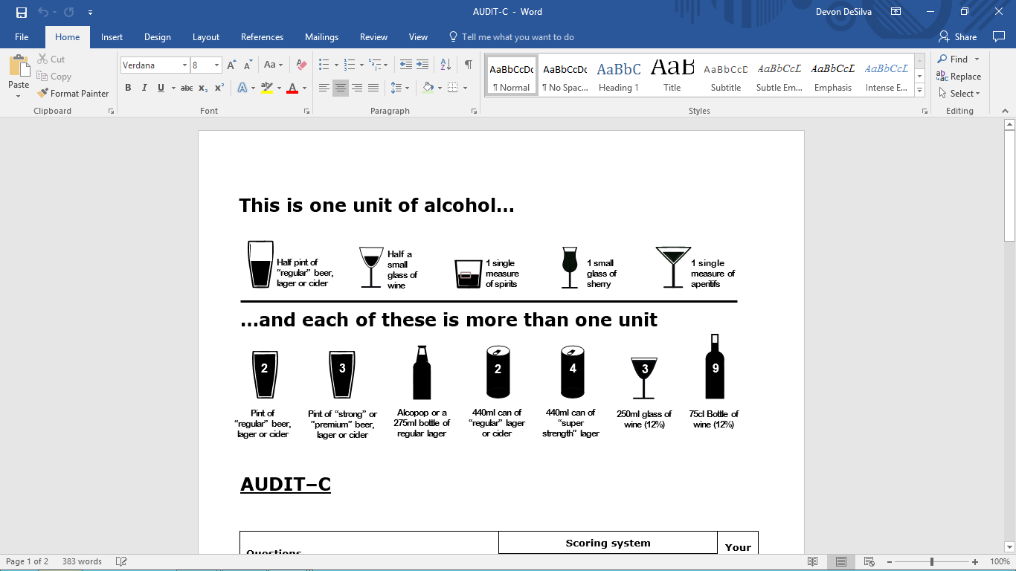
Appendix 1

